ASSESSMENT TOOL-2
OUTPUT

Question 1: AI-Powered Drone Emergency Medicine Delivery (A Search)*

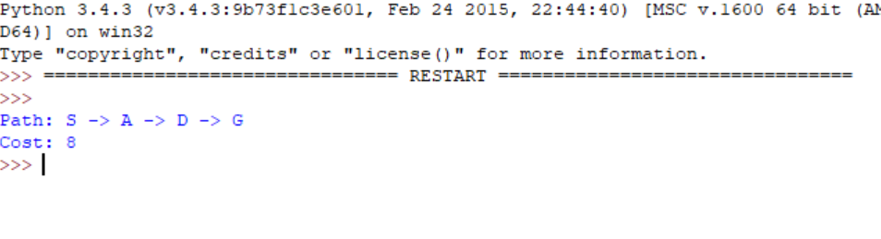
Question 2: Smart Traffic Signal Optimization (Hill Climbing)

Question 3: Mars Rover (Online Search)

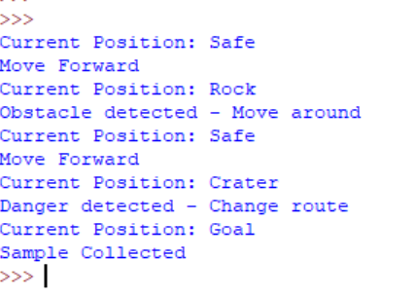

Question 4: University Exam Timetable (Backtracking CSP)

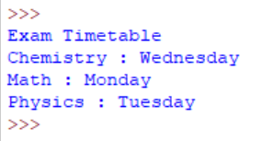

Question 5: Game AI (Minimax)

